References for Radar Project

Team No.: 18

Members:

Apurva Arya

Anshi Kandulna

# References:

Hrisko, J. (2020). Radar Emulator with Arduino + Python. Maker Portal. <https://makersportal.com/blog/2020/3/26/arduino-raspberry-pi-radar#python-code>

Learned radar GUI from this video but later made modifications:

<https://youtu.be/3jeLWl_nZ28?si=t1j95q6KaX6eflT4>

## Contributions:

Arduino code: Developed by Apurva and Anshi

Wiring and connections: Some help from ChatGPT

Hardware: Built by Apurva and Anshi

GUI: Based on Hrisko, J. (2020) but heavily modified by us

# Behind the Build: Insights and Assembly Process:

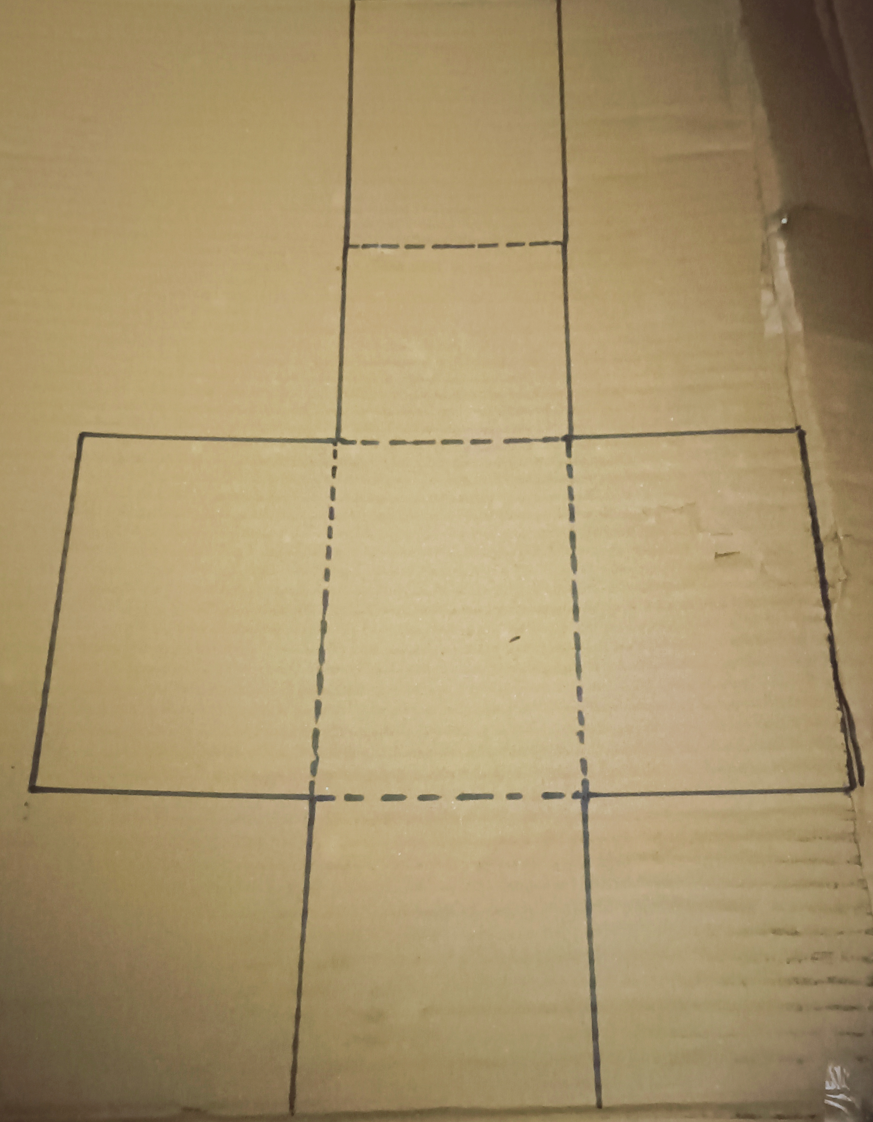 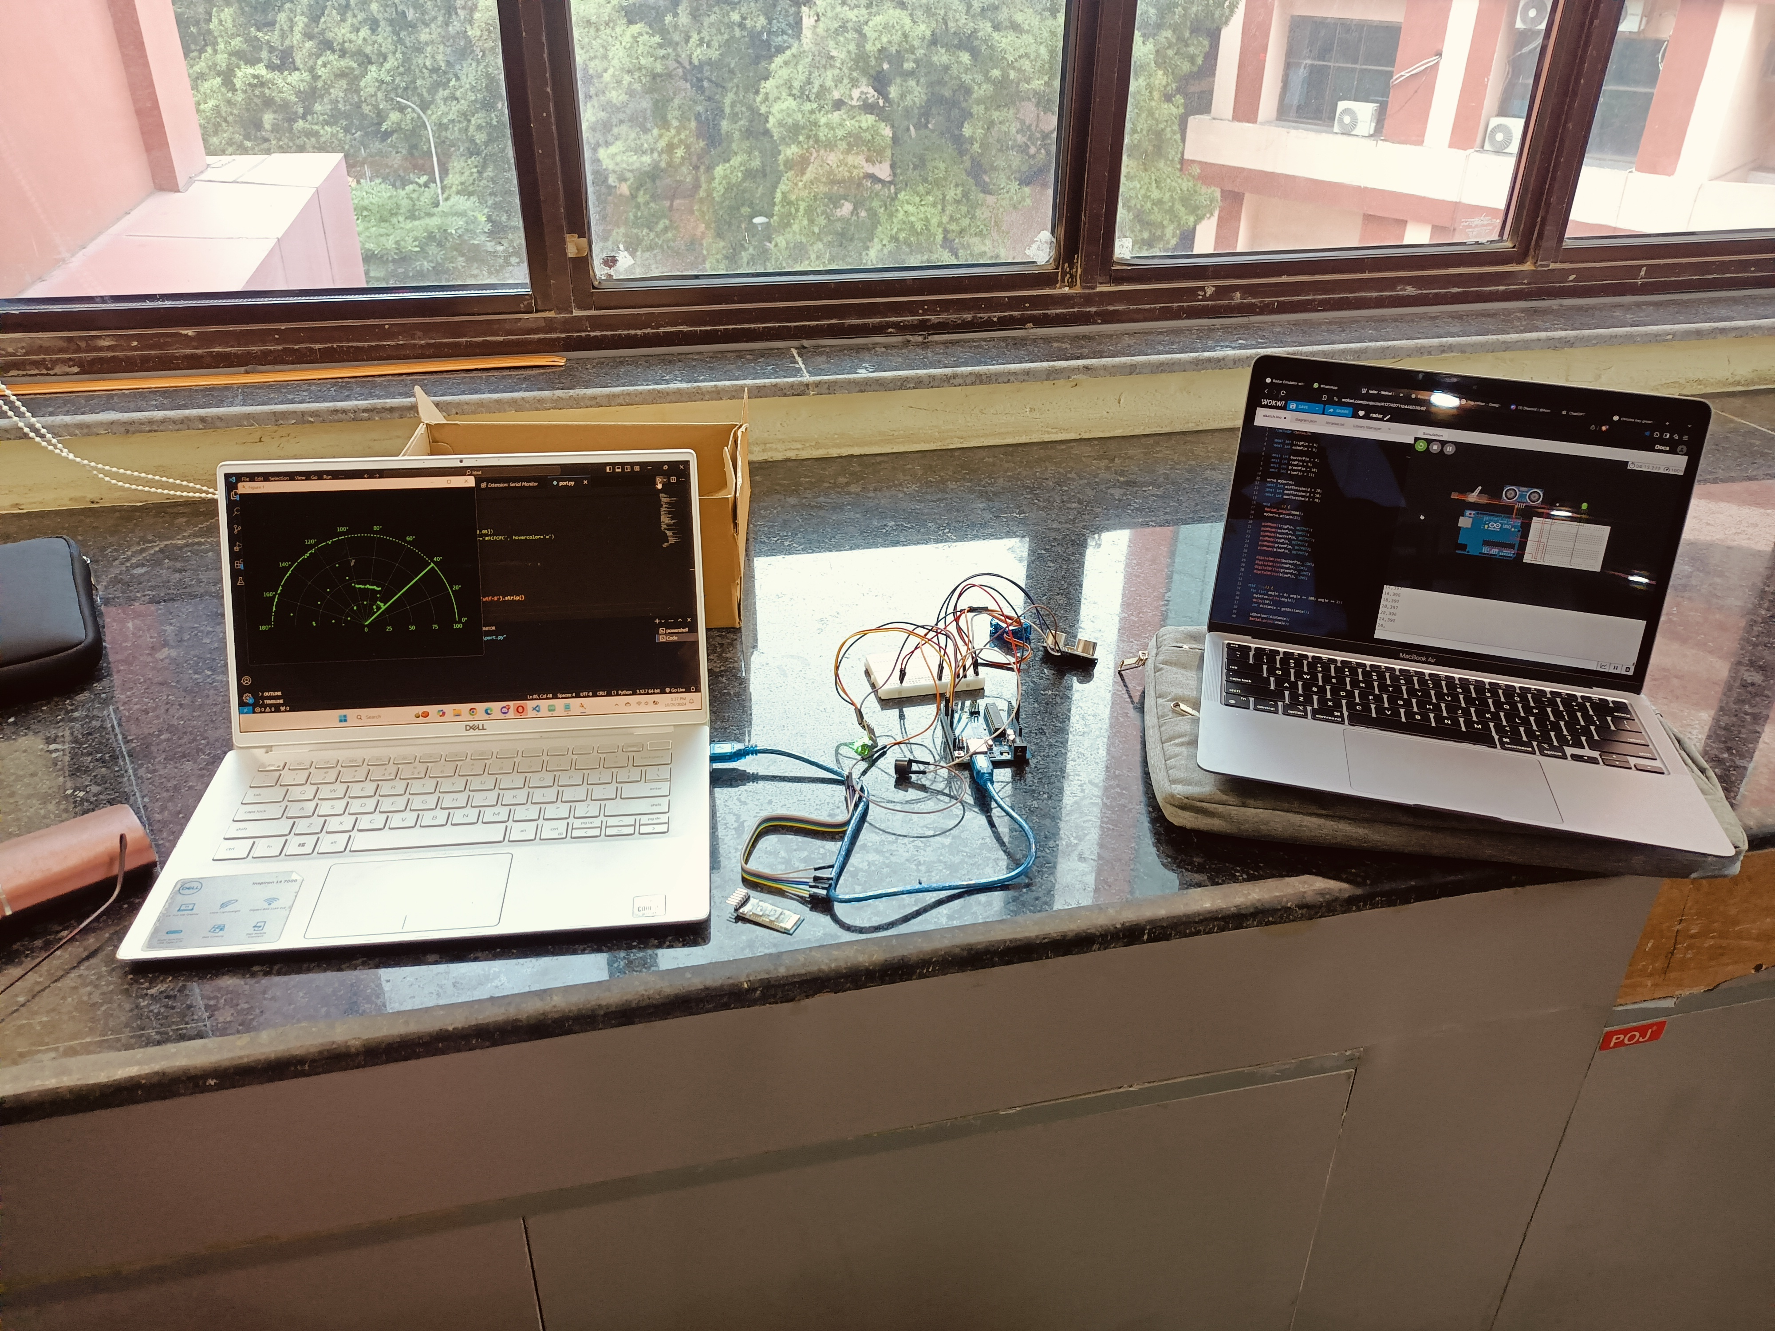

# Working Video :

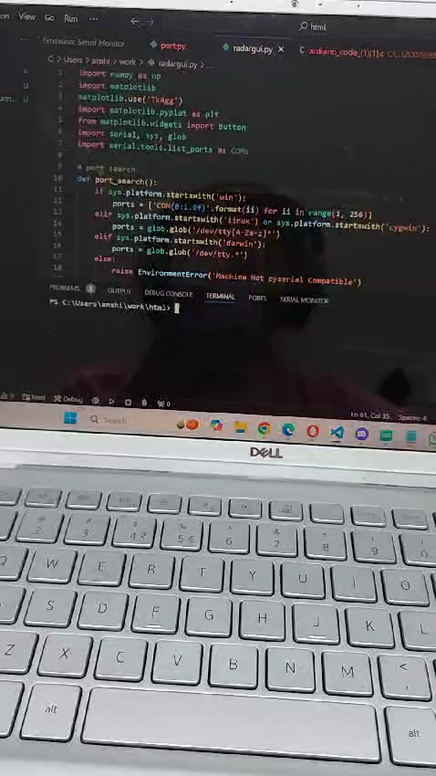

# Links to our Work:

Wokwi simulator(180): <https://wokwi.com/projects/412749711544603649>

GitHub Repo: <https://github.com/legendary-tree/Radar_System/>